WEB DEVELOPMENT HTML POE

Company name:

**BELTED**

ST10471498

Siyabonga Justice Dlamini

|  |  |
| --- | --- |
| Table of Contents | |
| Page 1 | Table of Contents |
| Page2 | Overview |
| Page 3 | Website goals and objectives |
| Page 4 | Products |
| Page 5 | Pictures |
| Page 6 | Design And User Experience |
| Page 7 | Timeline and Milestone |

# OVERVIEW

Belted is all about celebrating high quality products and craftsmanship. It is all about providing one of the key elements which completes an outfit, offering both practical benefits and style enhancement. Besides proving quality belts, the mission is to produce comfortable belts which are durable and one may rely on for years. The vision is to become a premier online destination for belt fanatics all over the world. Providing the best craftsmanship they ever encountered in the belt industry. Target audience are all belt enthusiasts, fashion forward individuals worldwide both male and female. Background- **BELTED** was founded by a man named John in 2015. He was researching about all the possible outcomes that may come from leather, which made have an idea of creating something that is sensational in the fashion industry of belts.

**Figure 1** shows a picture of the kind of products belted produce.

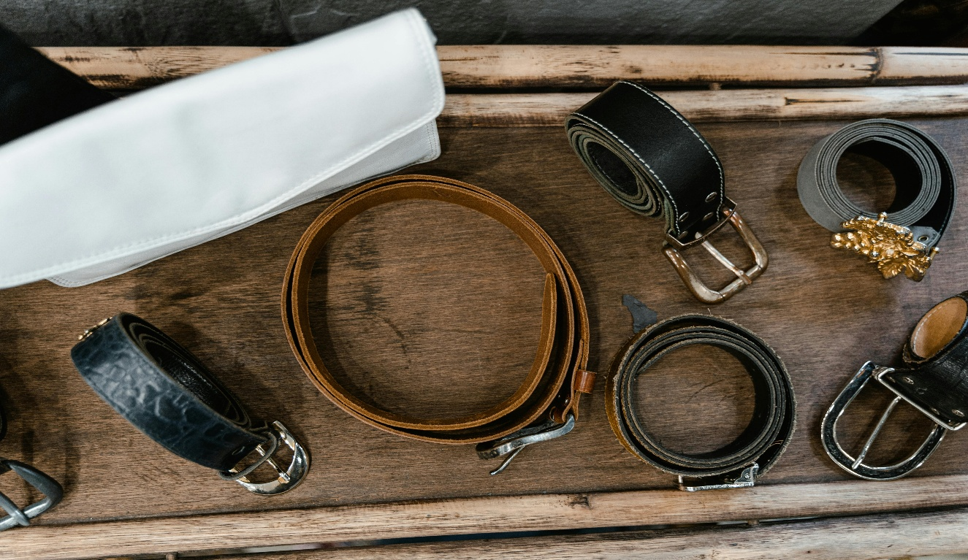

Figure 1; https://www.pexels.com/@mart-production/

**Website goals and objectives**

* **Sell:** Offers a simple user friendly website which is freely accessible to any user globally with numerous options to choose from.
* **Brand awareness:** To elucidate belts as a trusted authority in the niche of belts.
* **Educate:** To offer a broad mindset about belts on the culture of fashion and evolution of craftsmanship.
* **Measurable objectives:** a) Achieve 5000 users within 3 months.

b) Generate more than R70 000 sales with the first year.

**Proposed website features and functionality**

* HOME PAGE: The home page is visually appealing, easy to navigate. It includes a header and a

Footer. At the header there’s a logo and a navigation menu.

It also have welcoming words describing the company.

**LOGO;**

**SLOAGAN: *outfit completed!***

* About-us page: It will tell all about the establishment of the company on when it was created

Including the founder. It will also include all partners of the company.

* Contact page: It will include all contact details about the company. This will help customers

Easily access the products they need simpler if the need enquires.

* Products/services page: It will outline all the essential products needed by customers. It will also

Include pricing, images of the products, specifications and descriptions.

**Products**

FIGURE 2 shows one of the products that belted sell

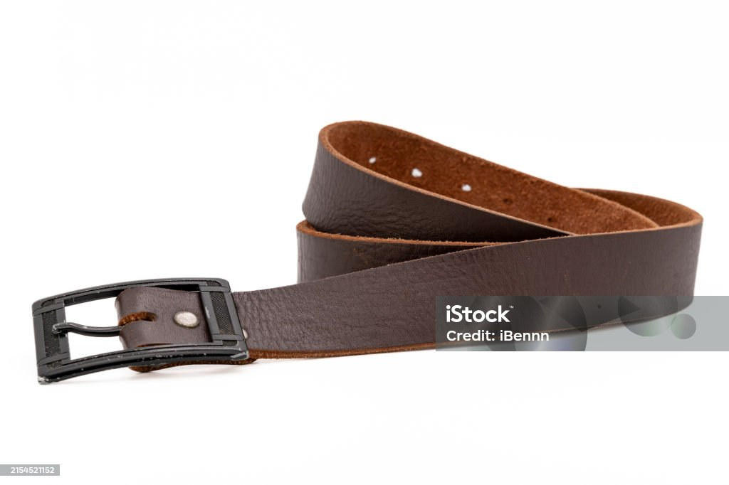

Figure 2: Images, G. (2025, April 4). Worn-mens-leather-belt-in-a-dark-brown-color-with-a-metal-buckle-on-white-background-gm. Retrieved from https://www.istockphoto.com/photo/worn-mens-leather-belt-in-a-dark-brown-color-with-a-metal-buckle-on-white-ba

* The product page will show high quality pictures of different kinds of belts where a belt fanatic will have many options to choose from. It will show a clear craftsmanship of belted as most of the produce made by belted are leather. The will suit both male and females. On this page that’s where they will also choose the size they want, color they prefer and choose from all the prices they think will suit them. It also show the product’s date manufacture so that customers may see BELTED as company to trust as it will be selling new unused manufacturers.

FIGURE 3 shows female belts.

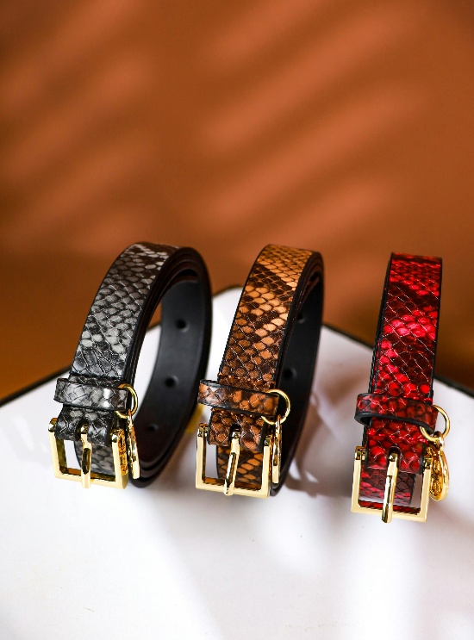

Figure 3: Jii, @. (2025, April 4) colored-belts-on-white-surface-8539466. Retrieved from <https://www.pexels.com/photo/colored-belts-on-white-surface-853946>

FIGURE 4 shows a males belt.

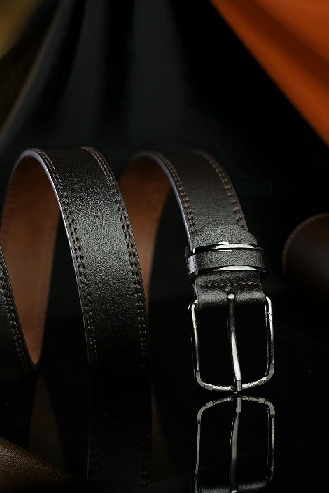

Figure 4: Patil, S. (2025, April 4). Luxury-leather-belt-with-metallic-buckle-31432650. Retrieved from <https://www.pexels.com/photo/luxury-leather-belt-with-metallic-buckle-31432650>

FIGURE 5 shows various kinds of belts.

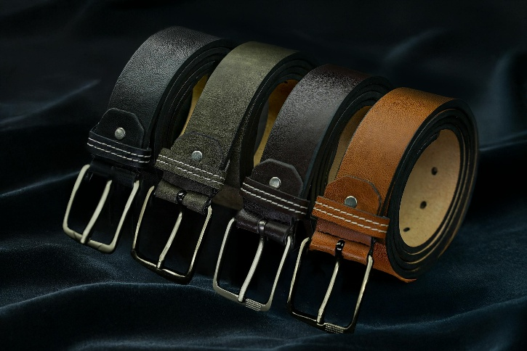

Figure 5: Patil, S. (2025, April 4). Luxury-leather-belts-in-various-shades-31367060. Retrieved from https://www.pexels.com/photo/luxury-leather-belts-in-various-shades-31367060/

**DESIGN AND USER EXPERIENCE**

* The color scheme will be leather brown to evoke craftsmanship.
* Clean modern typography with a nod to historical serif fonts.

***NEVIGATION***

* Home
* Contact
* About us
* Product
* Store

**USER EXPERIENCE**

* Fast-loading page with no ads.
* High quality images.
* Accessibility compliance like keyboard navigation.

***TECHNICAL REQUIREMENTS***

* HTML

**TIMELINE AND MILESTONES**

* Month 1: Planning and design(April 2025)

1. Design website.
2. Content strategy and initial product sourcing.

* Month 2-3: Development (May-June 2025)

1. Fix all problems encountered by users.

**BUDJECT**

Design and development: R20 000

Maintenance: R 7000

*TOTAL ESTIMATED COST: R 27 000.00*